**Lab 11 Tasks**

**20K-1052 (S.M.HASSAN ALI)**

**Q1.**

#include<iostream>

using namespace std;

class Employee{

public:

string name;

string code;

Employee(string n,string c):name(n),code(c){

}

};

class Consultant: virtual public Employee{

public:

int yoex;

Consultant(int y,string n,string c):yoex(y),Employee(n,c){

}

};

class Manager: virtual public Employee{

public:

int noteam;

Manager(int no,string n,string c):noteam(no),Employee(n,c){

}

};

class ConsultantManager: public Manager, public Consultant{

public:

ConsultantManager(int no,int y,string n,string c):Manager(no,n,c),Consultant(y,n,c),Employee(n,c){

}

display(){

cout<<"The employee name is: "<<name<<endl;

cout<<"The employee code is: "<<code<<endl;

cout<<"The no of years of experience for consultant is: "<<yoex<<endl;

cout<<"The no of teams for manager are: "<<noteam<<endl<<endl;

}

};

int main(){

ConsultantManager c(17,5,"ALI","S-123");

c.display();

return 0;

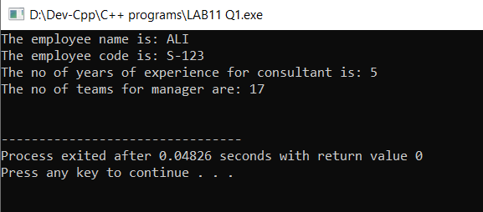}

**Q2.**

#include<iostream>

using namespace std;

class Vehicle{

public:

string toc;

int make;

string colour;

int year;

int md;

Vehicle(string toc,int make,string colour,int year, int md):toc(toc),make(make),colour(colour),year(year),md(md){

}

};

class GasVehicle: public virtual Vehicle{

public:

int fts;

GasVehicle(int f,string toc,int make,string colour,int year, int md):fts(f),Vehicle(toc,make,colour,year,md){

}

};

class ElectricVehicle: public virtual Vehicle{

public:

int es;

ElectricVehicle(int e,string toc,int make,string colour,int year, int md):es(e),Vehicle(toc,make,colour,year,md){

}

};

class HeavyVehicle: public GasVehicle,public ElectricVehicle{

public:

int weight;

int now;

int length;

HeavyVehicle(int wei,int now,int len,int e,int f,string toc,int make,string colour,int year, int md):weight(wei),now(now),length(len),ElectricVehicle(e,toc,make,colour,year,md),GasVehicle(f,toc,make,colour,year,md),Vehicle(toc,make,colour,year,md){

}

};

class HighPerformance: public GasVehicle{

public:

int hp;

int ts;

HighPerformance(int hpp,int tss,int f,string toc,int make,string colour,int year, int md):hp(hpp),ts(tss),GasVehicle(f,toc,make,colour,year,md),Vehicle(toc,make,colour,year,md){

}

};

class SportsCar: public HighPerformance{

public:

SportsCar(int hpp,int tss,int f,string toc,int make,string colour,int year, int md):HighPerformance(hpp,tss,f,toc,make,colour,year,md),Vehicle(toc,make,colour,year,md){

}

gearbox(){

cout<<"There are two types of gear box\n\t 1-Manual 2-Automatic"<<endl;

}

drive_sys(){

cout<<"There are two types of drive system\n\t 1-Rear wheel 2-Front wheel"<<endl;

}

};

class ConstructionTruck: public HeavyVehicle{

public:

ConstructionTruck(int weight,int now,int length,int e,int f,string toc,int make,string colour,int year, int md):HeavyVehicle(weight,now,length,e,f,toc,make,colour,year,md),Vehicle(toc,make,colour,year,md){

}

cargo(){

cout<<"The cargo item needs cement, gravel and sand\n";

}

};

class Bus: public HeavyVehicle{

public:

int nos;

Bus(int nos,int weight,int now,int length,int e,int f,string toc,int make,string colour,int year, int md):nos(nos),HeavyVehicle(weight,now,length,e,f,toc,make,colour,year,md),Vehicle(toc,make,colour,year,md){

}

Display() {

cout << "\t\t\n\t Type of Car: " << toc<<endl;

cout << "\t\t\n\t Make: " << make<<endl;

cout << "\t\t\n\t Colour: " << colour<<endl;

cout << "\t\t\n\t Type: " << toc<<endl;

cout << "\t\t\n\t Year: " << year<<endl;

cout << "\t\t\n\t Miles Driven: " << md<< " km\n";

cout << "\t\t\n\t Feul tank size: " << fts<<" litres\n";

cout << "\t\t\n\t Energy Storage: " << es<<" Joules\n";

cout << "\t\t\n\t Weight: " << weight<<" Tons\n";

cout << "\t\t\n\t Number of wheels: " << now<<endl;

cout << "\t\t\n\t Lenght: " << length<<" m\n";

cout << "\t\t\n\t Number of seats: " << nos<<endl;

}

};

int main(){

Bus b1(2,1750,4,20,490,40,"Mercedez",2018,"Grey",2021,999);

b1.Display();

